Step 1

Go to Penelope’s Homepage, on the right side of the webpage, Select Reports > View All Reports.



Step 2

Selecting “View all Reports” will lead you to the next webpage. Go to “Service Reports” > “Event Service Unit Detail Report”.



Step 3

A pop-up for Parameters will appear. Set the dates or range of date you need to check. Nominate the site the client/counsellor attended, event status should be set to “Show”, set Service > “FaRS Counselling” or “Family Law Counselling Group”, and nominate the client’s counsellor.

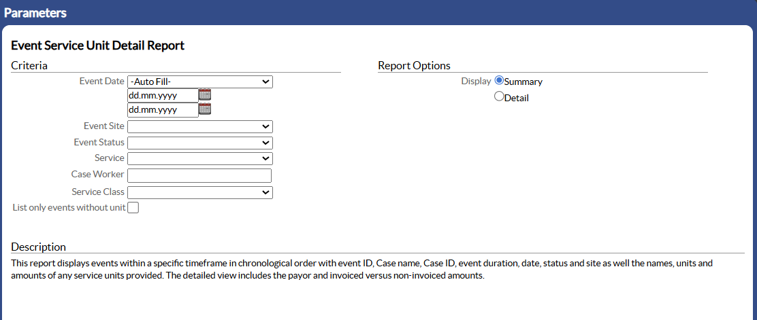

Step 4

Important – Set Report Options to “Detail”.

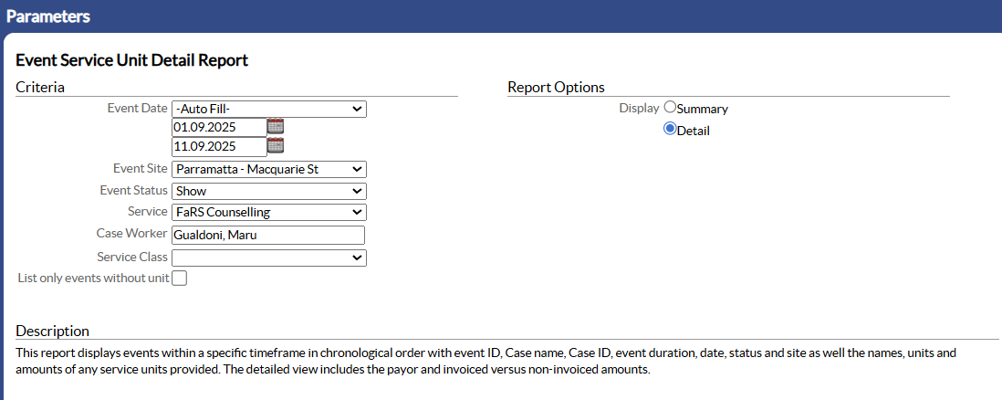



Step 5

At the bottom of the Parameter pop-up, choose “view” to generate the report.



Step 6

The report is now generated and from here you can see who has yet to pay their fees and/or if a service unit has been carted for a client’s session.

For Norfolk Island – Primary Funding(1) will show, at this stage, client from Norfolk Island will NOT be charged for counselling fees.

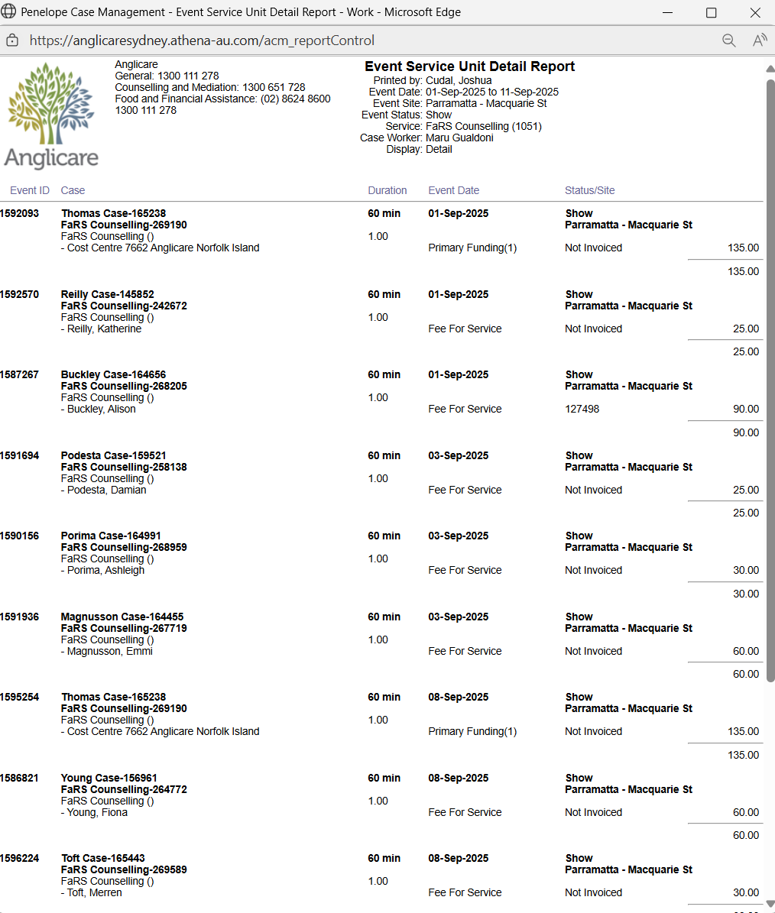



For uncarted service units, the report will show “There are no Service Units for this event.” From here, we can see which sessions we need to cart a service unit for and then process payment with “Quick Pay”.

